**2.0 Database Documentation**

2.1 ***Database development in Microsoft Access***

Database management tools such as Microsoft Access (MS Access) is a widely used software is today’s era and we have used this tool to create an separate ABT tables for each of the Data’s and linking it with the different insurance policies to individually identify the data quality issues and analyse the table.

Here are the following steps :-

1. First we have loaded the data in the Ms Access through External Data -> New Data source and loaded all four file naming Customer, Health Policies, Motor Policies, Travel Policies.
2. With the help of an image we can understand the structure of the data :-

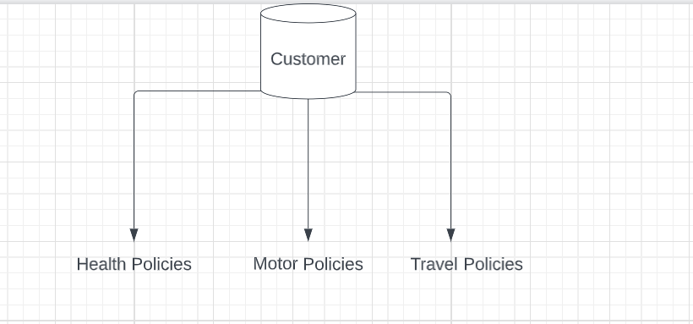

We have three Database related to insurance other than the main being Customer data about the insurance policies.

1. So before joining we have used a Distinct command to remove any duplicate values for all the database which include Customer, Health Polices, Travel Policies, Motor Policies and renamed them as NoDup (No Duplicate) files.

The we have included a chart of overall database structure in which we have merged the Customer_NoDup with Health_NoDup, Travel_NoDup, Motor_NoDup using **INNER JOIN** and created separate ABT (Analytical Base Tables). So, analysis will be through and modifying and linking each Insurance policies to its customer data will be levelled.

1. The table are linked using Inner Joins and the primary key in Customer_NoDup is CustomerID keeping that we have created ABT.
2. There are few limitations in the current approach as we can’t use advance visualization techniques after solving the data quality issues and Tableau and Rstudio is a much better option when dealing with data which are categorical and numerical in nature.

***3.0 INSIGHT REPORT***

Further we will discuss the in-depth ANALYSIS of the data by comparing few variables and establishing a relation between these variables and how these variables affects the over Customer Characteristics while buying an insurance products.

1. **Microsoft Access Analysis**

* In MS Access we have established a relationship between Average Age and Location under ABT Health Table.

Here we can analyse that People staying in rural areas have Subscribed to more health insurance as compared to urban areas. As more Rural People are more aware regarding the policies which is a useful thing to note onto.

* Further we have established a relationship between Average vehicle value in ($10,000) and Location.

Here also we can see that the average values of rural and urban areas have a slight difference. Through which we can analyse that the prople staying in rural areas has a high value car and thus they would usually subscribe to a Motor Insurance.

* Further we have established a relationship between Motor insurance type as per location.

Here it can be seen that most people have preferred Single Insurance polices in both the Location as compared to Bundle Insurance.

* In this we have tried to establish an analysis between the Average Age and Travel Type.

Here we can see that many young people prefer Backpacker travel type with an average age of 25, Business and premium Travel group are on the lower side after Backpacker. Most of them prefer Standard Travel type out of all.

* In this we have tried to establish an analysis between Travel Type as per their Location.

Out of this we can analyse that Minimum people preferred Backpacker travel type as compared Standard Travel type which is the maximum in both Rural and Urban areas.

* Here we can see the relation between Com channels as per their location.

Here we can see that most of them in both Urban and rural settlement prefer SMS as an service of communication so the companies need not to invest more in carrier calling services and postal methods.